Primary Visual Arts
Welcome to the 2016 school year! It’s been wonderful to welcome all ISS Primary students into the new Visual Arts classroom, located in the MPH mezzanine. We have a much bigger classroom space, and we’ve found it absolutely ideal for all our learning and creative purposes so far.
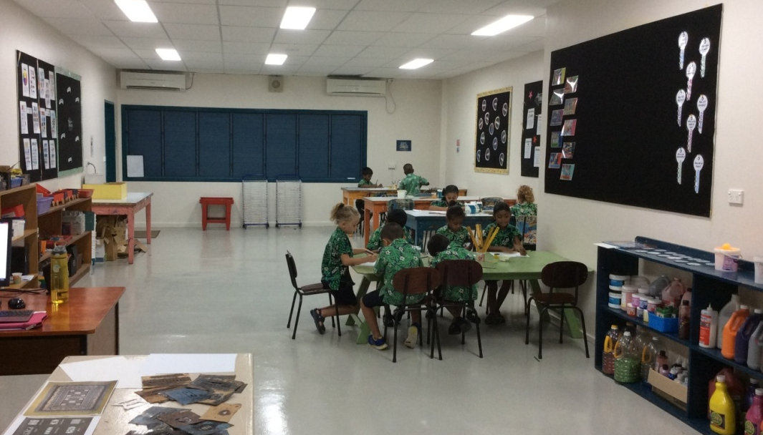
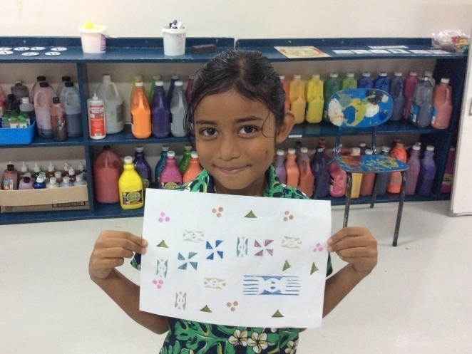
Also new to the Visual Arts program this year is our online Art Gallery through Artsonia, known as the world’s largest student art museum. Perhaps the most exciting aspect of this for you as a parent or caregiver is that your child is establishing a digital portfolio of artwork. The portfolio is available for you to view and manage from the Artsonia app on your device or directly from the Artsonia website, and can move with your student if the time comes to move to a new country or new school. Your child will be bringing home a notification of participation, with his or her Artsonia username and your parent access code. You can look for this within the next week or two, if you haven’t received it already. Please let me know if you have any questions about Artsonia, or if you would like assistance with your child’s account anytime. My email address is lstice@international.school.fj . Thank you for your continued support! -Lindy Stice

