Primary Visual Arts

It’s been a great term! ISS primary students have demonstrated commitment to their learning, and have shown enthusiasm in learning and applying new art skills. Deep and creative thinking has pushed us to new understandings. We have had so much fun, though we’ve also shed a few tears in the art room following TC Winston. We have reflected on friendships, and our identities both individually and in our families and cultures. We have enjoyed expressing our ideas through our artwork.
Thank you to all families who have created a parent account on Artsonia to view our online gallery and your child’s digital art portfolio. All students in ECH1 through Reception should have received account information already, and some students in Year One and Year 2. Thank you for your patience as I prepare the remaining accounts. Would your child like to add a title or artist statement to one of his or her art works? Here’s how: Tap “Student” on the login page (or go to www.artsonia.com/class and use the code WMNF-ZJMX or scan the QR code below.
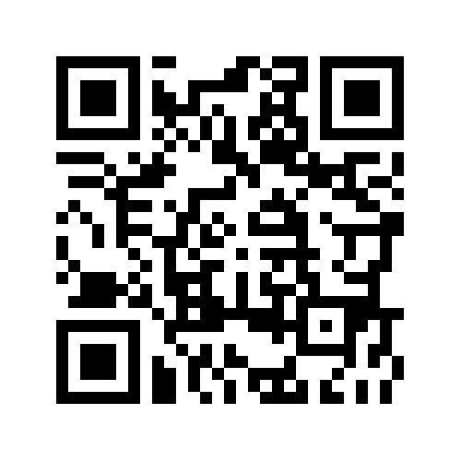

Now you or your child can add a title or an artist’s statement on any piece in his or her portfolio, if he or she hasn’t yet done so in the art room.
I wish you all a wonderful first school holiday, and look forward to continuing our creative adventures in Visual Arts in Term 2.
Mrs Lindy Stice

