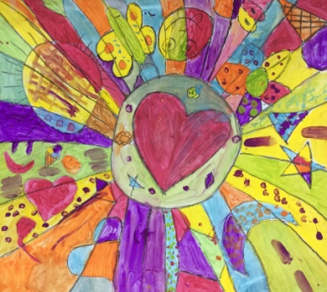Primary **Visual Arts**

*Bula from the Art room!*

*We wrapped up last term with a collaborative art-making session for years 4 and 5, in celebration of the International Day of Happiness. Each mural (see top right) was created by about 20 students, and was bursting with color and energy! If you like it, you’ll love the work of Romero Britto, which inspired our murals.*

*Year Four worked tremendously hard on their inquiry into the interrelatedness of human body systems. The inquiry concluded this term with a task that allowed students to demonstrate this interrelatedness by depicting two systems on a multi-layered collaborative art piece. These were on display at the Year 4 breakfast, and are now on a display table at the library if you wish to have a look.*

*Years 1, 2, and 3 are currently creating major art works that are- or will soon be- uploaded to our Artsonia gallery.*

*Early Childhood and Reception are, as always, delighted to explore art concepts by making and playing in the Art room.*

*Thanks for supporting our young artists! It is great to hear about their continued learning in out-of-school artistic endeavors. –Mrs Lindy Stice*

